OS Assigment-1 | SimpleLoader
Group ID-16
Members: Vaibhav Samrat Waghaye | 2024597, Rigzin Gyalpo | 2024458
Contributions:
Vaibhav -> iteration to locate PT_Load segment, calling _start, error handling
Rigzin -> reading and seeking ELF file and headers, calling _start, error handling
Implementation: The loader first opens the ELF file and checks for errors, then allocates memory for the ELF header (ehdr) and reads it in. Next, it allocates memory for the program header table (phdr), seeks to the correct file offset, and reads all entries. It then iterates through the program headers to locate a PT_LOAD segment that contains the entry point of the executable.
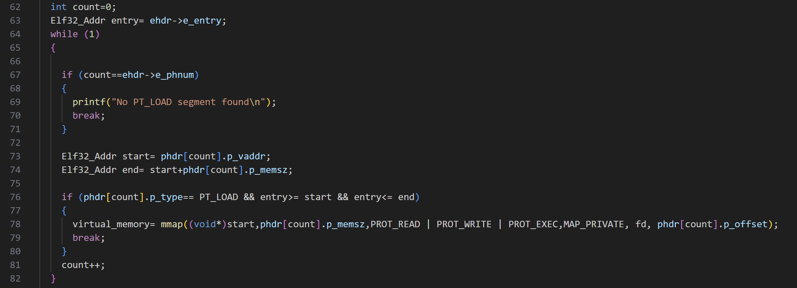
Once found, it uses mmap to map that segment into memory with read, write, and execute permissions. The loader then computes the offset of the entry point within this mapped segment, casts it to a function pointer, and invokes the _start function defined inside the ELF, printing its return value.
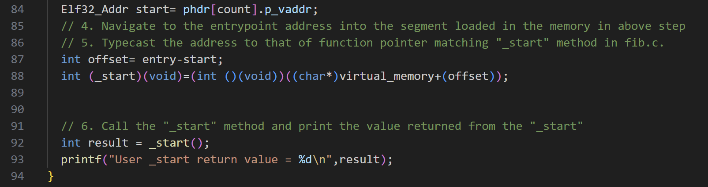
After execution, it performs cleanup by freeing the allocated memory for ehdr and phdr, and closing the file descriptor, while the main function ensures valid command-line arguments, invokes the loader, and finally calls the cleanup routine.
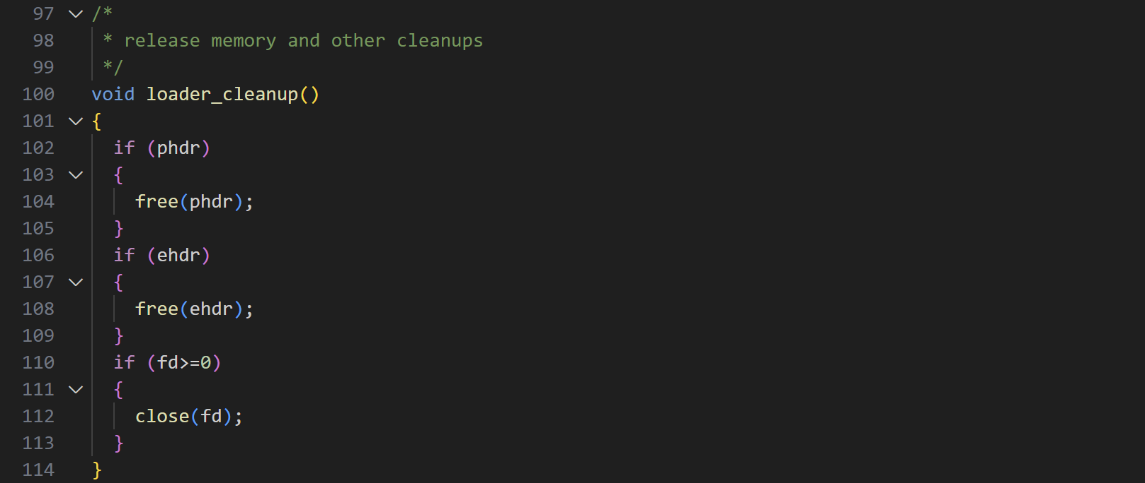
List of error checks:
- File open failure.
- ELF header memory allocation failure.
- ELF header read failure.
- Program header table memory allocation failure.
- Seek to program header offset failure.
- Program header table read failure.
- No PT_LOAD segment found.
GitHub Repository Link: https://github.com/vaibhavsw27/group-16.git

